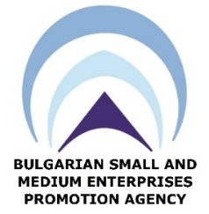
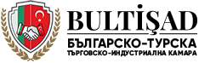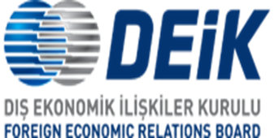

Draft, 26th October 2018
BULGARIA – TURKEY
BUSINESS FORUM
19th November (Monday) 2018
Venue: | Ramada Sofia City Centre, Maria Luiza 131 Blvd Sofia, Bulgaria 1202

09:30 – 10:00 | Registration /Welcome coffee
10:00 – 11:00 | Official Opening Ceremony, Hall …….,  Moderator: tbc  - Opening remarks by H.E. Mr. Emil Karanikolov, Minister of Economy, Republic of Bulgaria  - Key note speech by H.E. Mrs. Ruhsar PEKCAN, Minister of Trade, Republic of Turkey  - Address by Dr. Alexander Minev, Executive Director, BSMEPA  - Address by Mr. Nail Olpak, President, DEİK  Q&A Session
11:00 - 12:00 | Trade and Investment Opportunities between Bulgaria and Turkey
12:00 – 13:00 | Moderator: Mr. Branimir Mladenov, General Manager, Sarten Bulgaria(tbc)  Presentations:  - Mr. Stamen Yanev, Director, Bulgaria Investment Agency  - Mr. Osman Ak, Chairman, DEİK Turkey – Bulgaria Business Council  - Ms. Antoneta Bares, Executive Director, Bulgaria National Industrial Zones Company  - Mr. Edis Emre, President, Bulgarian-Turkish Chamber of Commerce (BULTİŞAD)  Panel: Bulgaria as a Logistics Hub and Investment Environment in Bulgaria (tbc)  - Mr. Fikret İnce, Chairman, Alcomet AD  - Mrs. Fazilet Çavdar, Branch Manager, T.C. Ziraat Bankası Bulgaria  - KRIB representative  - Mr. Ahmet Hampolat, Chairman, VITO Europe OOD  Q& A Session
13:00 – 17:00 | Luncheon & Networking / В2В session

